Sprint Plan Document

# Heading

Sprint {3} Plan

Team number: 5, Section: 47406

Team member 1: Sara al-meshrai, ID: 435202339

Team member 2: Nora Alkhunifer, ID: 435201094

Team member 3: Asmaa Alrubia, ID: 435200178

Sprint start at: 16/11/2017

Sprint competition at: 21/11/2017

# Goal

In this sprint, we will complete our work on implement main page thin we will build the app on IOS to test accessibility for studio photos and camera in the device. Also, we will test and get our project test result for completed phases, finally we will add a notification feature.

# Task listing, organized by user story

User story 1 “As a user, I want the dishes list ordered by high rating, so that I know what is the best dishes.”

Task1: develop function to show it with high rating. (time estimate for task 1 is 1h)

Total for user story:1hour

User story 2 “As a user, I want to search by dish’s name, so that I save some time.”

Task 1 description: creating the search field. (2 hours)

Task 2 description: filtering the dish list based on the user input. (4 hours)

Total for user story 3: 3days

User story 3 (As a user, I want to able to ' like ' mark a dish so that my favorites dishes are arranged)   
~~Task 1: create an empty heart icon. (1 hour)~~  
~~Task 2: fill the icon while user hovering on it. (1 hours)~~  
Task 3: save the heart icon as filled if the user click on it. (2 hours)  
Task 4: save the dish as liked by the user in the database. (3 hours)  
Task 5: empty the heart icon if user click on it again. (2 hours)  
Task 6: remove the dish as liked form this user in the database. (3 hours)  
Total for user story 5: 2 days

User story 4 “As a user of app, I want to view list of shop in app .”

Task 1: download the match icons and styles. (1hour)

Task 2: develop card view .(2 hours)

Task 3: implement scroll list view. (4 hours)

Task 4: connect with database. (1 hour)

Task 5: Code Review (2 hours)

Task 6: testing. (3 hours)

Task 7: Acceptance testing. (1 hour)

Total for user story 7: 14 hours

User story 5 (As a user, I want to Sort the dishes list according to my need, so that I find what I want easily.)

Task1: develop filter on this page depend on user needs (5hours)

Total for user story:5 hours.

­

User story 6 (As a user of app, I want to rate any dish in app so that the system will add my rating on that dish)

~~Task 1: Start with CSS and bootstrap accomplishes a graphic for each of the three states: by defaults empty, full, and highlighted. (1 hour)~~

~~Task 2: Implement rating function to calculate dish rating base on specification (3 hours)~~

Task 3: Connect The rating function with database to save rating (2 hours )

Task 4: Test unit [ rating function] (2 hours)

Total hours of user story 9 :8 hours

User story 7 “As a developer I want to link the implemented project to ionic dashboard and link all members with it in order to make it public for all clients”

Task 1: implement needed code for link (5 hours)

Task 2: test the connection (6 hours)

Task 3: upload it to ionic viewer (1 hour)

Total for user story 12: 2 days

User story 8 (As a user, I want to receive successful message, so that’s I can confirm my account via email.)

Task1 description: Develop the part of sending email for account confirmation.

Task2 description: Code Review.

Task 3 description: Write unit tests.

Total for user story 16: 1day

User story 9 (As a user, I want to edit my profile photo, so that I can keep my profile up to date)

Task 1 description: Develop change profile photo functionality.

Task 2description: Add the new photo to profile table in the DB.

Task 3 description: Code review.

Task 4 description Unit testing.

Task Total for user story 21: 1day

User story 10 (As a user, I want to filter the displayed list by dish kinds, e.g: sweet, cake, so that I Minimize the dishes options.)  
Task 1 description: create a button corresponds to every dish type in the database. (1 hour)  
Task 2 description: link the button with a code that displays the dishes with that kind. (4 hours)

Task 3 description: label the clicked button. (1 hour)  
Total for user story 4: half a day

User story 11 (As a user, I want to filter the displayed list by event or meeting type e.g. party, visit a friend, so that I Minimize the dishes options)  
Task 1 description: create a button corresponds to every event or meeting type in the database. (2 hours)  
Task 2 description: link the button with a code that displays the dishes having that meeting type. (5 hours)  
Task 3 description: write the code that allows more than one button to be clicked. (4 hours)

Task 4 description: make the clicked buttons labeled. (1 hour)  
Total for user story 3: 2 days

# Initial task assignment

Asmaa Alrubia: user story 3,6,9, all tasks

Nora Alkhunifer: user story 2,4,11, all tasks

Sara al-meshrai: user story 1,3, 10 all tasks

**Initial burndown chart**

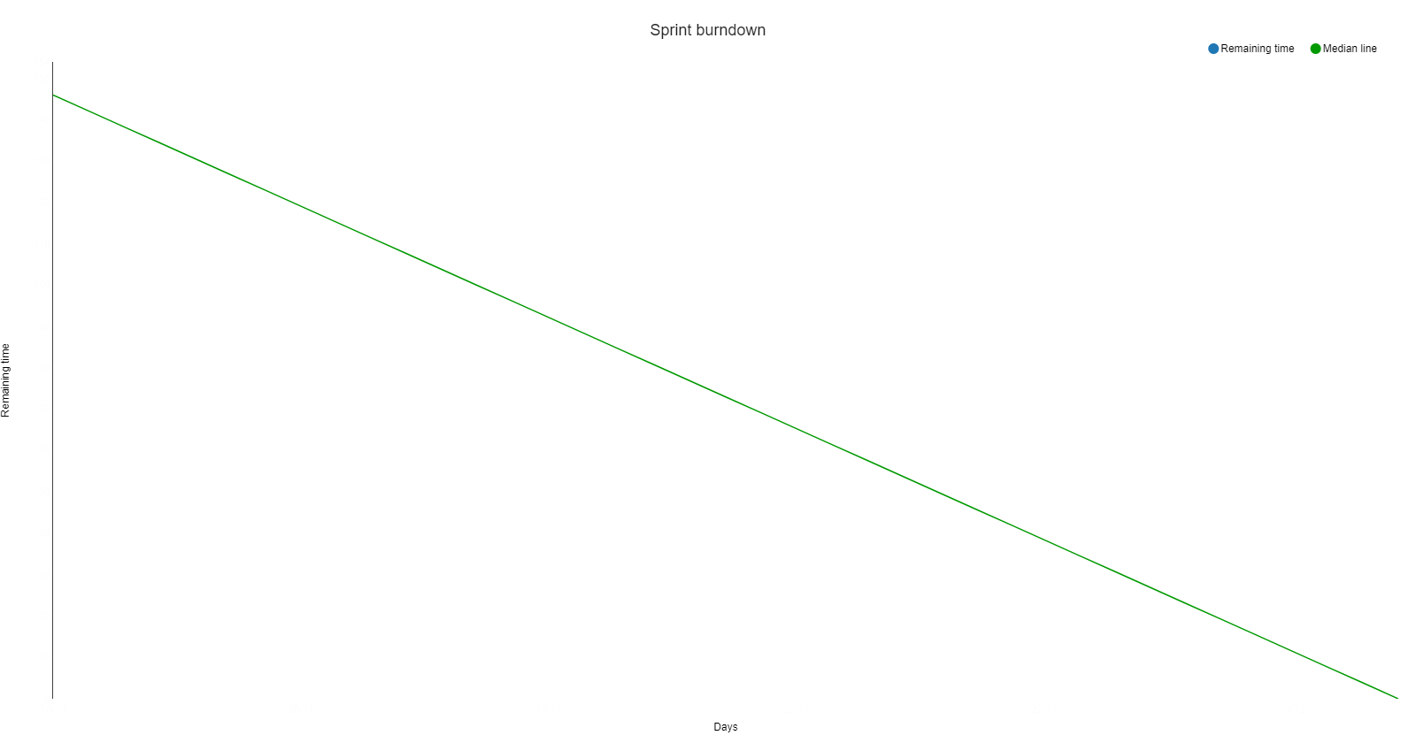

**Initial scrum board**

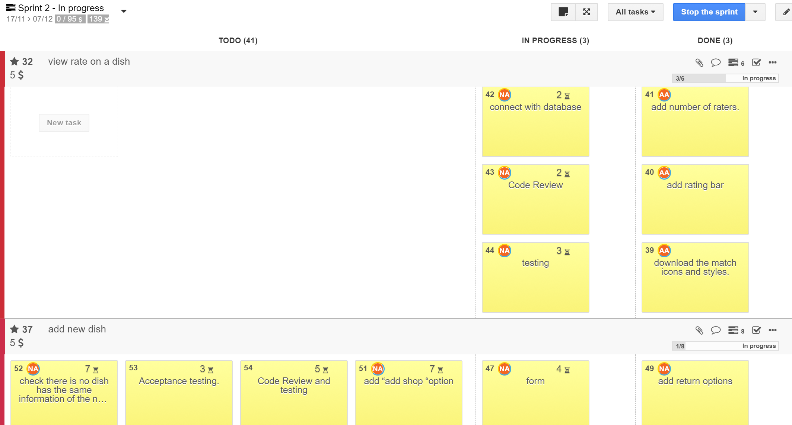

# Scrum times

Every Tue 1-3PM.

Every Thu 8-10AM.

Every Friday 8-10AM.